Seth Grieser

SES350

Dr. Engelen

5/03/2020

SES350 Final Project

This is my simulation of the 2020 NBA Playoffs using each team’s PPG. Each series is best of 7, and playoff matchups are set based on the regular season standings from when the 2020 NBA season was suspended.

Western Conference:

#1 Lakers vs. #8 Memphis Grizzles

Lakers win series 4-2

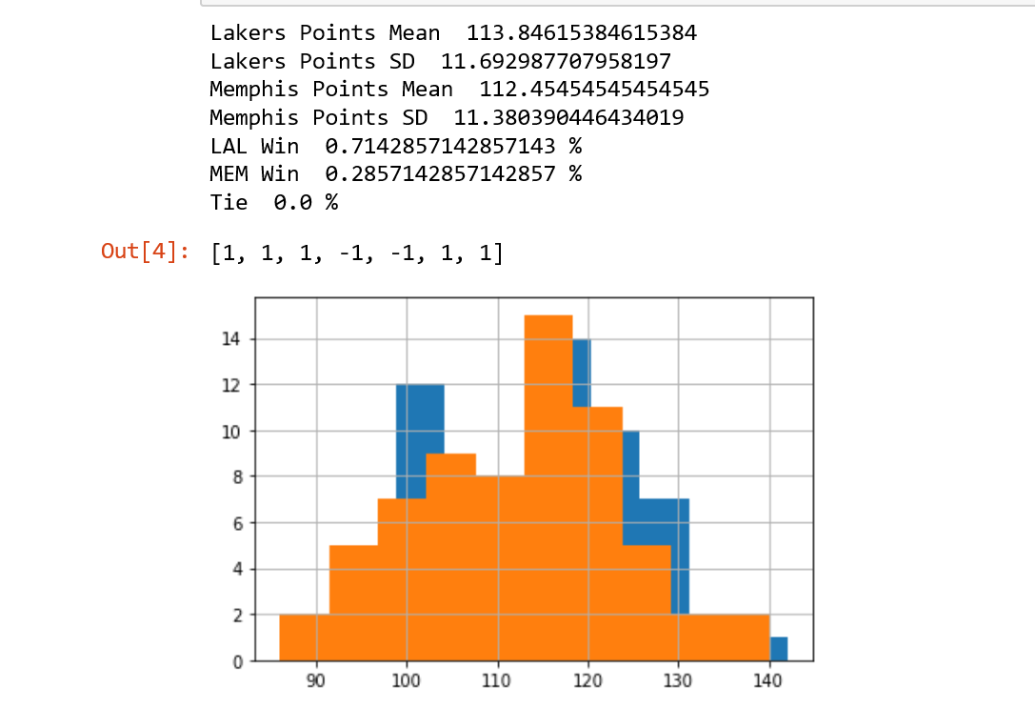

# 2 Clippers vs. #7 Dallas Mavericks

Clippers win series 4-2

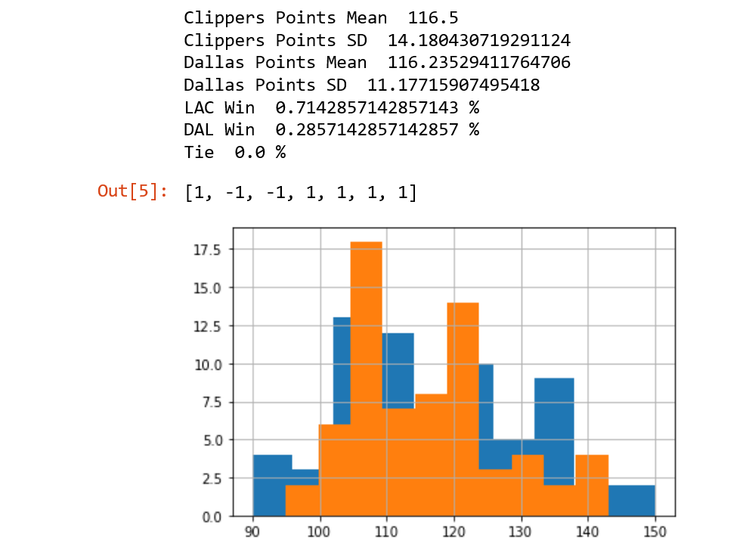

#3 Denver Nuggets vs. #6 Houston Rockets

Nuggets win series 4-3

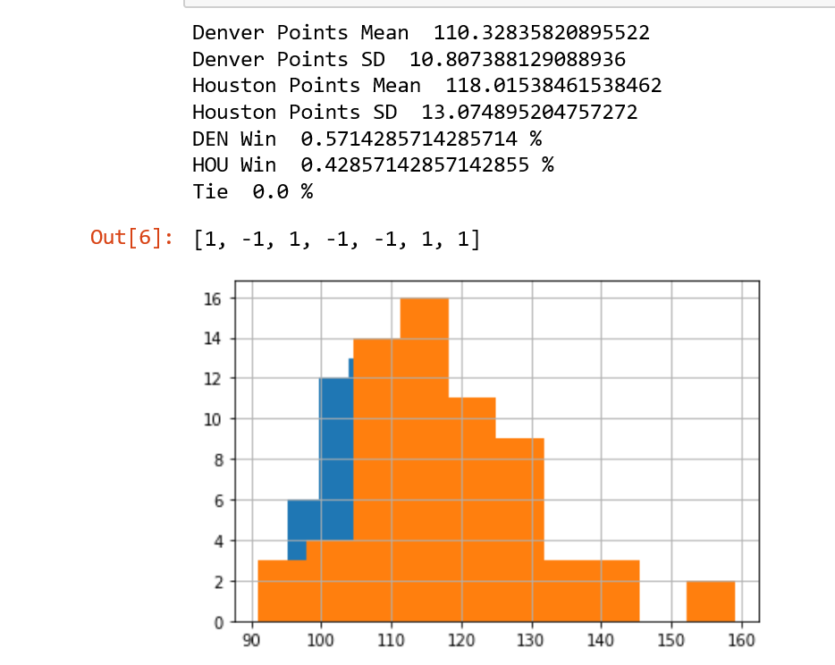

# 4 Utah Jazz vs. #5 Oklahoma City Thunder

OKC wins series 4-1

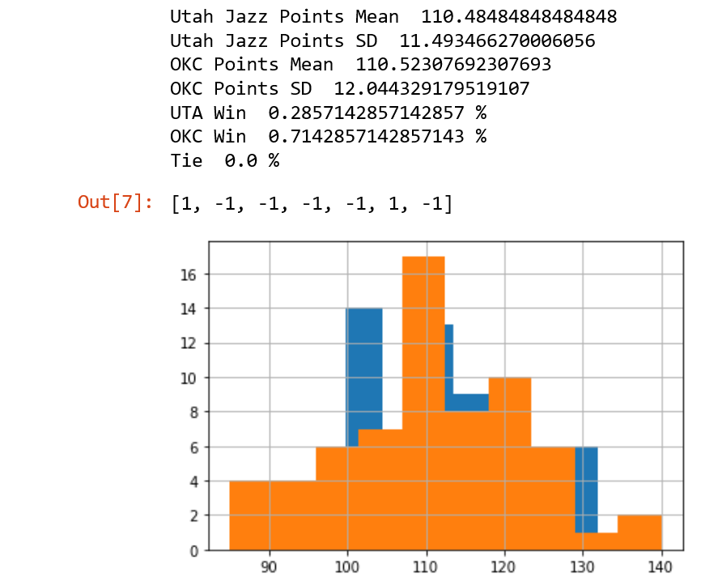

Western Conference Semifinals:

#1 Lakers vs. # 5 OKC

Lakers win series 4-1

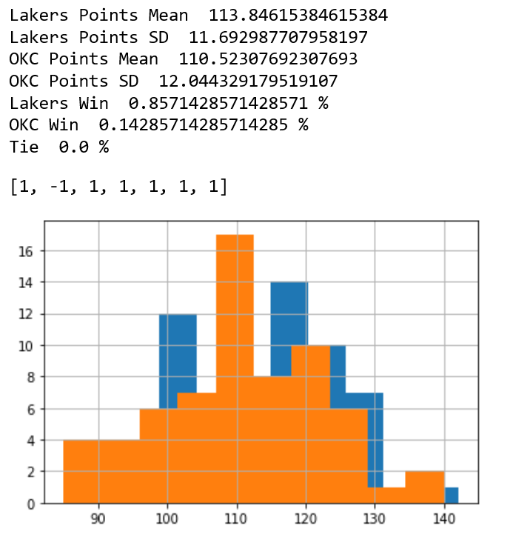

# 2 Los Angles Clippers vs. # 3 Denver Nuggets

Clippers win series 4-0

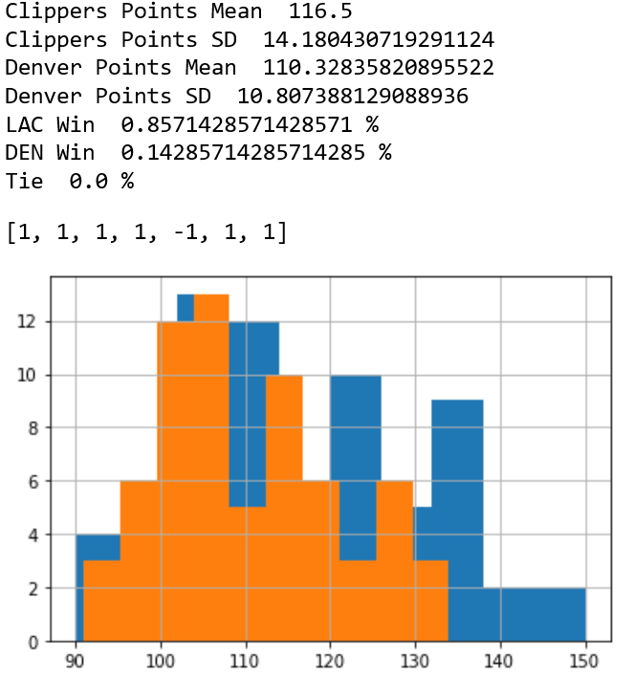

Western Conference Finals: #1 Los Angles Lakers vs. # Los Angeles Clippers

Clippers win series 4-3

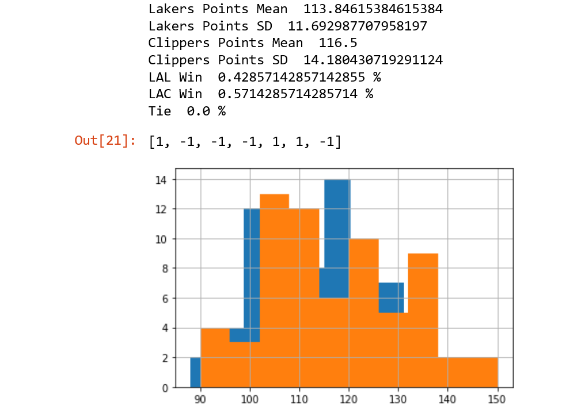

Eastern Conference: #1 Milwaukee Bucks vs. #8 Orlando Magic

Bucks wins series 4-1

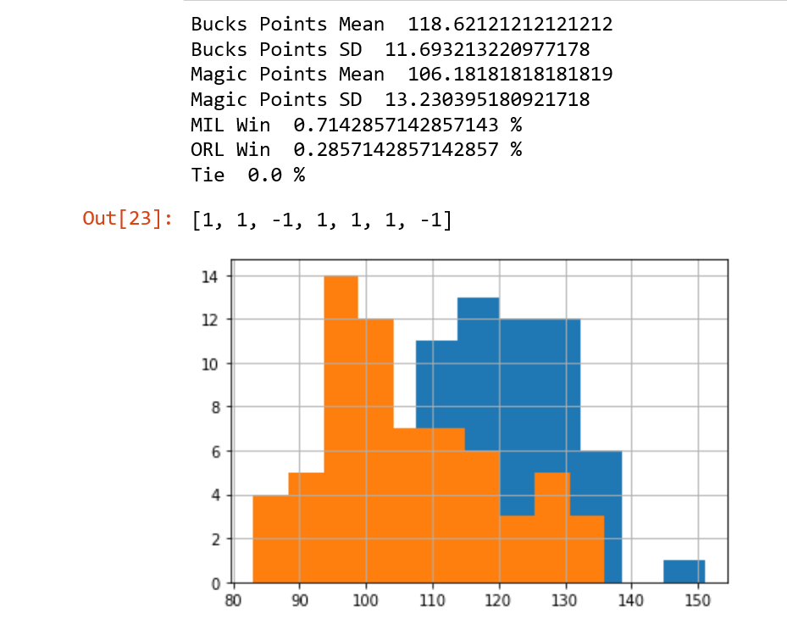

#2 Toronto Raptors vs. #7 Brooklyn Nets

Toronto win series 4-1

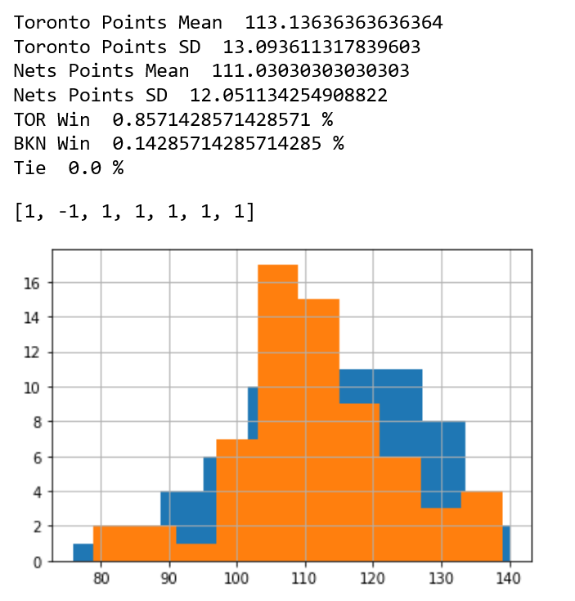

#3 Boston Celtics vs. #6 Philadelphia 76ers

76ers win series 4-1

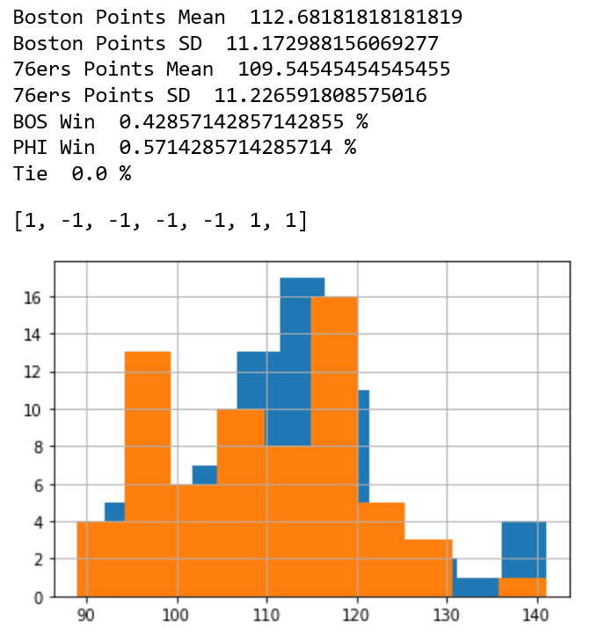

# 4 Miami Heat vs. #5 Indiana Pacers

Miami wins series 4-0

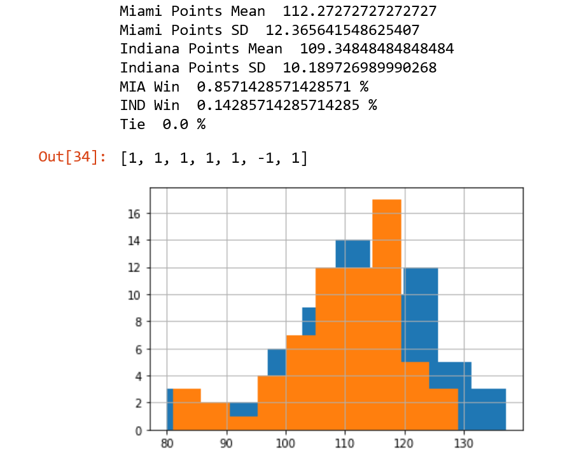

Eastern Conference Semifinals: #1 Milwaukee Bucks vs. # 4 Miami Heat

Bucks win series 4-0

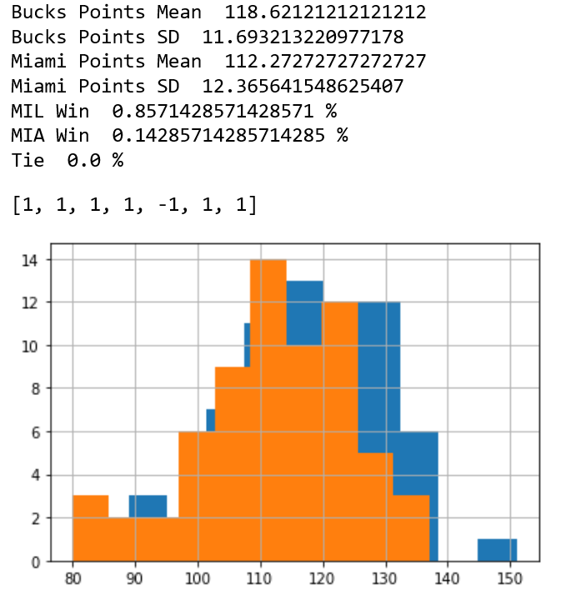

# 2 Toronto Raptors vs. # 6 Philadelphia 76ers

Toronto win series 4-3

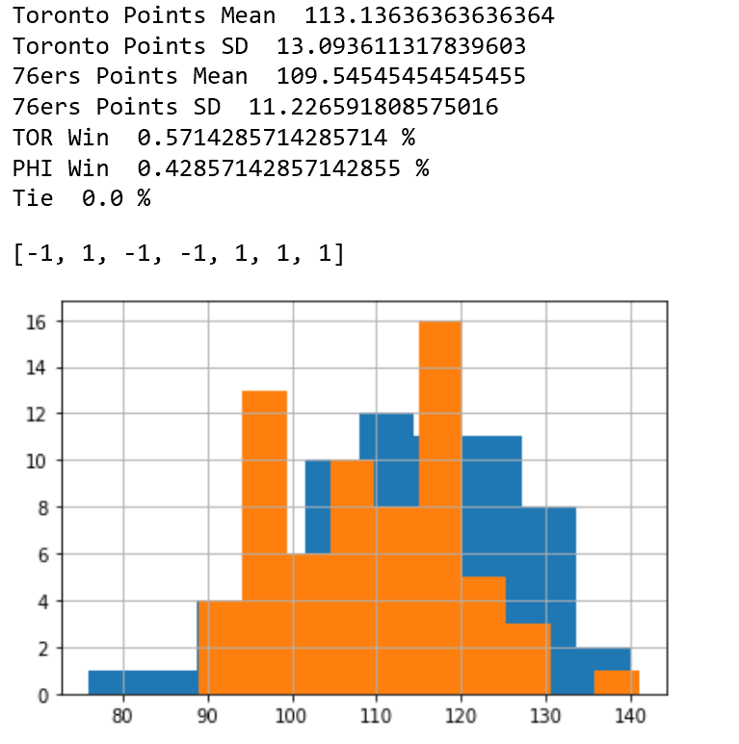

Eastern Conference Finals: #1 Milwaukee Bucks vs. #2 Toronto Raptors

Bucks win series 4-2

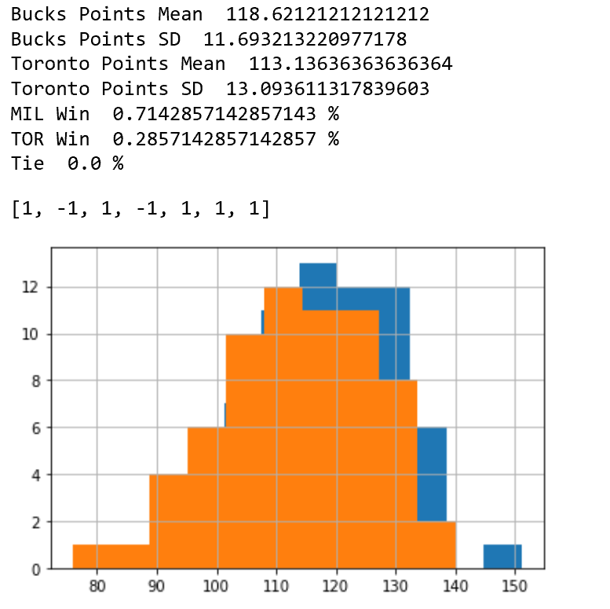

NBA 2020 Finals: #1 Milwaukee Bucks vs. # Los Angeles Clippers

Bucks win NBA Finals 4-2

